ANSWERS TO ASSIGNMENT 1

**ENVIRONMENT SET-UP**

1.Installing windows 11

Step 1: Create a bootable USB drive

Materials:

* USB drive with at least 8GB of storage space
* Windows 11 ISO file

Instructions:

* [Download the Windows 11 ISO file](https://www.microsoft.com/en-us/software-download/windows11) from Microsoft's website.
* [Use a tool like Rufus](https://rufus.ie/) to create a bootable USB drive from the ISO file.

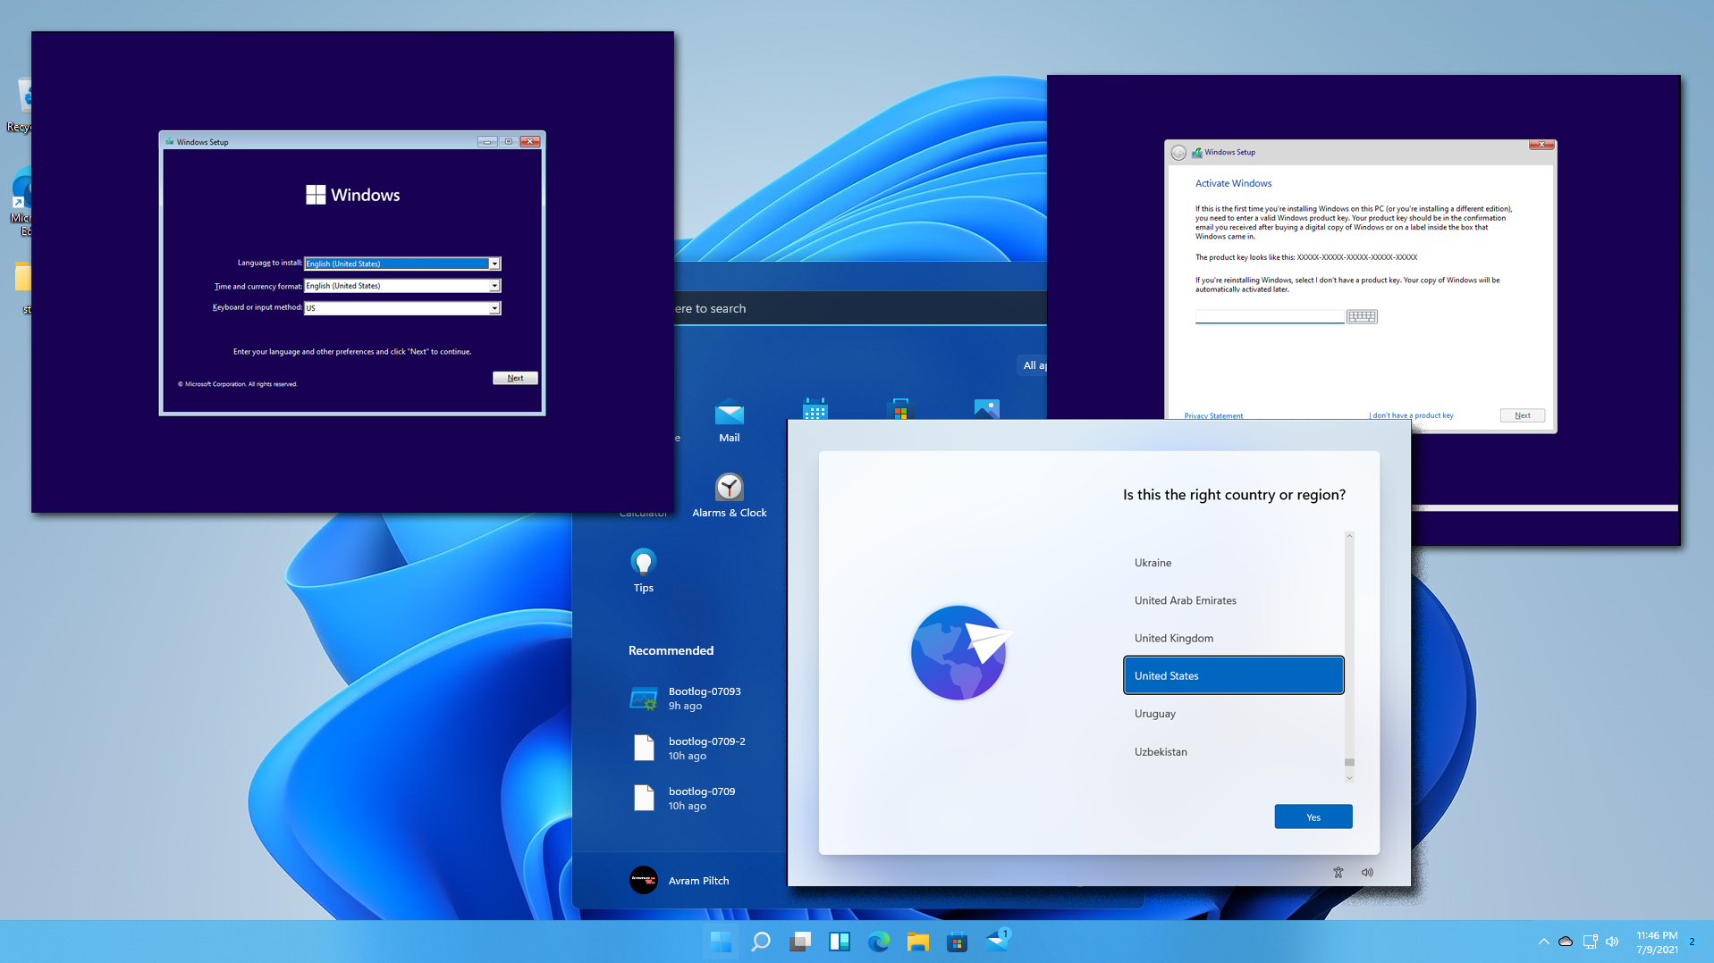

Step 2: Boot from the USB drive

Instructions:

* Insert the USB drive into a USB port on the computer you want to install Windows 11 on.
* Turn on the computer and press the key that is displayed on the screen to enter the BIOS settings.
* In the BIOS settings, change the boot order so that the USB drive is the first boot device.
* Save the changes and exit the BIOS settings.

Step 3: Start the Windows 11 installation

Instructions:

* The computer will now boot from the USB drive.
* Select your language, time and currency format, and keyboard input method.
* Click "Next".

Step 4: Select the installation type

Instructions:

* Choose "Install Now".

Step 5: Accept the license agreement

Instructions:

* Select "I accept the license terms" and click "Next".

Step 6: Choose the installation type

Instructions:

* Select "Custom: Install Windows only (advanced)".

Step 7: Select the hard drive

Instructions:

* Select the hard drive where you want to install Windows 11.
* Click "Next".

Step 8: Install Windows 11

Instructions:

* The Windows 11 installation will now begin. This may take some time.

Step 9: Set up your user account

Instructions:

* Once the installation is complete, you will be prompted to set up your user account.
* Enter your username and password.
* Click "Next".

Step 10: Configure your settings

Instructions:

* You will now be asked to configure your settings, such as privacy, security, and updates.
* Make your selections and click "Next".

Step 11: Finish the installation

Instructions:

* Windows 11 will now finish the installation process.
* Once the installation is complete, your computer will restart.

Congratulations! You have now successfully installed Windows 11.

2.How to install Visual Studio Code

Step 1: Download the Visual Studio Code Installer

* Visit the official Visual Studio Code download page: https://code.visualstudio.com/download
* Choose the installer for your operating system (Windows, macOS, or Linux).

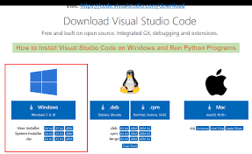

Step 2: Run the Installer

* Once downloaded, run the installer.
* Follow the on-screen instructions to complete the installation.
* If prompted, accept any user agreements or privacy policies.

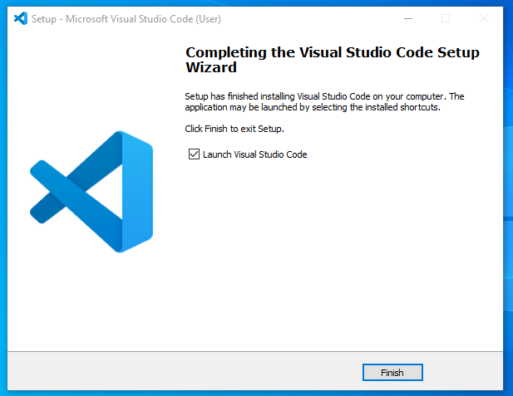

Step 3: Launch Visual Studio Code

* After the installation is complete, you can launch Visual Studio Code from the Start menu (Windows), Applications folder (macOS), or terminal (Linux).

Step 4: Install Extensions (Optional)

* Extensions enhance the functionality of Visual Studio Code.
* To install extensions, open the Extensions Marketplace from the View menu.
* Browse and search for extensions that meet your needs.
* Click the "Install" button for extensions you want to add.

Step 5: Configure Your Settings (Optional)

* To customize your Visual Studio Code environment, open the Settings tab from the File menu.
* You can adjust settings such as theme, font size, keyboard shortcuts, and many more.

Step 6: Create a Workspace (Optional)

* A workspace is a collection of files and folders that you work on within Visual Studio Code.
* To create a workspace, click the "File" menu and select "Open Folder".
* Navigate to the folder containing the files you want to work on.

3.Installing and configuring Git

1. Download the Git installer: Visit the official Git website (https://git-scm.com/downloads) and download the installer for your operating system.
2. Run the installer: Double-click on the downloaded installer and follow the on-screen instructions to install Git.

Configuring Git

1. Open Git Bash: Launch Git Bash by searching for it in your start menu or application launcher.
2. Set your username: Run the following command to set your Git username:  
   git config --global user.name "Your Name"
3. Set your email address: Run the following command to set your Git email address:  
   git config --global user.email "your@email.address"
4. Verify your settings: Run the following command to verify that your settings are properly configured:  
   git config --list

Additional steps for specific operating systems

Windows:

* Enable line endings conversion: Open Git Bash and run the following command:  
  git config --global core.autocrlf input

macOS:

* Install Xcode Command Line Tools: Xcode Command Line Tools are required for additional command-line utilities. Install them via the App Store.

Linux:

* Install Git dependencies: Depending on your distribution, you may need to install additional dependencies. For example, on Ubuntu:  
  sudo apt install git-core

4.Installing Python

Windows:

1. Visit the Python download page: https://www.python.org/downloads/
2. Click on the latest stable Python version for Windows.
3. Run the downloaded executable file (e.g., "python-3.10.0-amd64.exe") and follow the installation wizard.

macOS:

1. Install the macOS Command Line Tools:  
   xcode-select --install
2. Install Homebrew:  
   /usr/bin/ruby -e "$(curl -fsSL https://raw.githubusercontent.com/Homebrew/install/master/install)"
3. Install Python using Homebrew:  
   brew install python

Linux:

Use your package manager to install Python:

* Debian/Ubuntu:  
  sudo apt-get install python3
* Fedora/Red Hat:  
  sudo yum install python3
* CentOS/Rocky Linux:  
  sudo dnf install python3

Setting Up Python

Add Python to PATH (optional):

1. Open the system environment variables settings (e.g., System Preferences on macOS, Control Panel on Windows).
2. Add the following path to the PATH variable:
   * Windows:  
     C:\Python310  
     (assuming Python is installed in  
     C:\Python310  
     )
   * macOS/Linux:  
     /usr/local/bin  
     (if using Homebrew)

Install a Package Manager (optional):

1. Install Pip (Python package installer):
   * Windows:  
     pip install pip
   * macOS/Linux:  
     python -m pip install pip --user
2. Install Virtualenv (virtual environment manager):  
   pip install virtualenv

Create a Virtual Environment (optional):

1. Create a virtual environment for your project:
   * Windows:  
     python -m venv my_venv
   * macOS/Linux:  
     python3 -m venv my_venv
2. Activate the virtual environment:
   * Windows:  
     my_venv\Scripts\activate
   * macOS/Linux:  
     source my_venv/bin/activate

5.Installing PIP

1. Check if Pip is Already Installed:

* Open a command prompt or terminal window.
* Type  
  pip --version  
  .

If Pip is already installed, the version will be displayed.

2. Install Pip Using Get-Pip Script:

* Windows:
  + Download the get-pip.py script from https://bootstrap.pypa.io/get-pip.py.
  + Open a command prompt as administrator.
  + Navigate to the directory where you downloaded the script.
  + Run  
    python get-pip.py  
    to install Pip.
* macOS / Linux:
  + Open a terminal window.
  + Run  
    curl https://bootstrap.pypa.io/get-pip.py -o get-pip.py  
    to download the script.
  + Run  
    sudo python get-pip.py  
    to install Pip as root.

3. Verify Installation:

* Run  
  pip --version  
  again to check if Pip is installed and to display the version.

4. Install pipx (Optional):

* pipx is a tool that helps manage and install Python packages in isolated environments.
* To install pipx, run  
  pip install pipx  
  .

5. Set Environment Variables (Optional):

* To use pipx globally, add the following to your shell configuration file (e.g.,  
  .bashrc  
  ,  
  .zshrc  
  ):

export PIPX_HOME="$HOME/.local/pipx"

export PATH="$PATH:$PIPX_HOME/bin"

6. Upgrade Pip (Optional):

* To upgrade Pip to the latest version, run  
  pip install --upgrade pip

.

6.Installing SQL Database

1. Download the Installation File:

* Visit the official website of the SQL database vendor (e.g., Microsoft for SQL Server, Oracle for Oracle Database, MySQL for MySQL)
* Locate the download page for the specific version you want to install
* Download the installation file (.exe, .tar.gz, etc.)

2. Start the Installation Process:

* Double-click on the installation file to launch the setup wizard
* Follow the on-screen instructions
* Select the target directory where you want to install the database software

3. Choose the Installation Type:

* Select the type of installation you want: full, custom, or express
* The full installation installs all optional components, while the custom installation allows you to select specific features and components

4. Configure the Database Instance:

* Specify the name of the database instance (e.g., "MY_DATABASE")
* Choose the database engine settings, such as the authentication mode and port number

5. Create a Database User:

* Create a database user and assign it a password
* This user will be used to manage and access the database

6. Install Additional Components (Optional):

* If needed, install additional components or tools, such as the management studio or other utilities

7. Configure the Firewall (Windows only):

* If you are installing on Windows, you may need to configure the firewall to allow connections to the database server

8. Start the Database Service:

* Start the database service to make it available for use
* Verify that the service is running smoothly

9. Verify Installation:

* Connect to the database using the user you created and check if you can execute queries and manage the database

Additional Notes:

* The specific installation steps may vary slightly depending on the SQL database software you are using
* If you encounter any issues during installation, refer to the official documentation or contact the vendor's support team
* You may need additional privileges or permissions to complete the installation and configuration process

7.Extensions and plug-ins for my IDE

Productivity Enhancements:

* Productivity Power Tools: A comprehensive suite of tools for code navigation, formatting, code analysis, and other productivity-boosting features.
* Resharper: A powerful IDE extension that provides code analysis, code navigation, unit testing, and a range of other tools to improve coding efficiency.
* CodeMaid: Automates code cleanup tasks like formatting, code style enforcement, and removing unused code.
* Visual Assist X: Enhances code editing with advanced auto-completion, context-sensitive help, and code refactoring tools.

Code Analysis and Debugging:

* Code Analysis: Provides static code analysis tools to identify potential errors and code smells before compilation.
* Roslynator: A code analysis tool that uses Roslyn to offer real-time code diagnostics and code generation features.
* Live Unit Testing: Enables unit testing directly in the IDE, providing instant feedback on code changes.

Version Control Integration:

* Azure DevOps Services: Integrates Visual Studio with Azure DevOps Services for source code management, task tracking, and continuous integration.
* Git Integration: Provides seamless integration with Git, allowing developers to manage their Git repositories directly from the IDE.
* TFVC Integration: Enables integration with Team Foundation Version Control (TFVC) to manage source code in a centralized repository.

Database Development:

* SQL Server Data Tools (SSDT): A comprehensive suite of tools for designing, developing, testing, and deploying SQL Server databases.
* Oracle Developer Tools for Visual Studio: Provides an integrated development environment for developing, debugging, and deploying Oracle databases.
* PostgreSQL: Integrates PostgreSQL with Visual Studio, enabling database development and management from the IDE.

Other Extensions:

* NuGet Package Manager: Manages NuGet packages for third-party libraries and frameworks.
* EditorConfig: Enforces consistent code style and formatting across the team.
* Window Resizer: Customizes window layout and resizing options for a more efficient workspace.
* VsVim: Adds Vim-like keyboard shortcuts and commands to the Visual Studio editor.